Creating a web site with Dream weaver templates.

1. Open dream weaver
2. 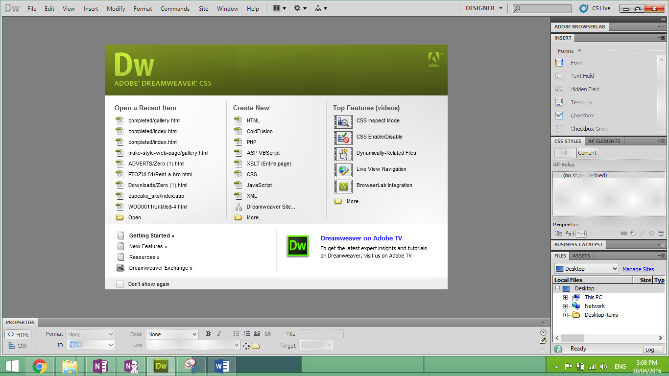Choose Create New, More
3. 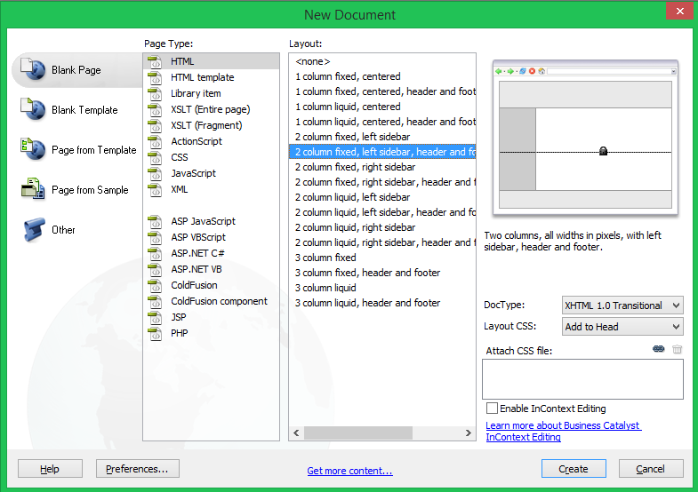You will be provided with a list of various templates.
4. Select a blank page, HTML, choose a suitable lay out, press create.
5. Your page will be created as shown below

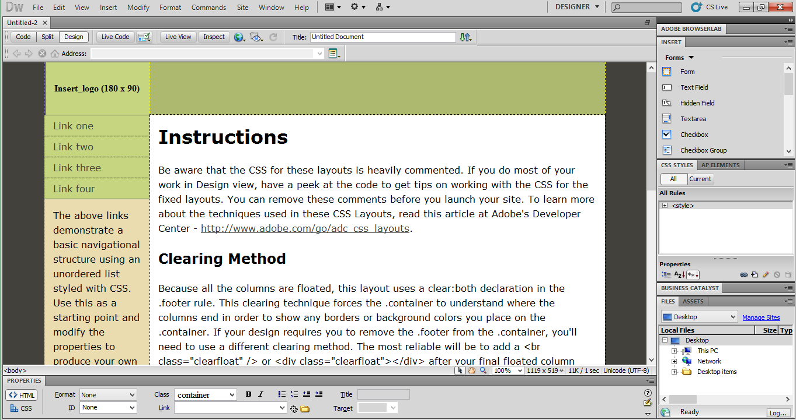

1. You are now able to save your page as Index.html to your preferred location.
2. Double click on insert logo in the top left corner to select and image. Ensure that all your images are stored in the same folder as where you stored your web page.
3. 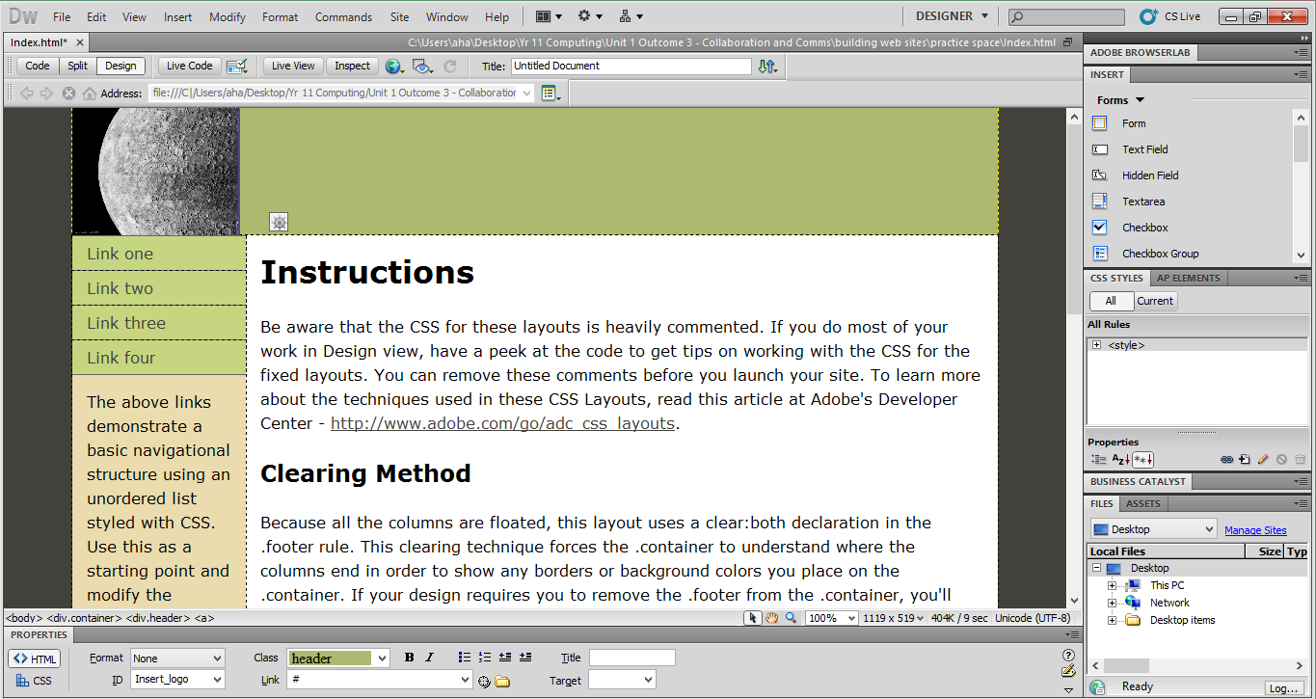You are able to resize the image by selecting the sizable corners of the image
4. You can then change much of the text on the page to your liking, see next image

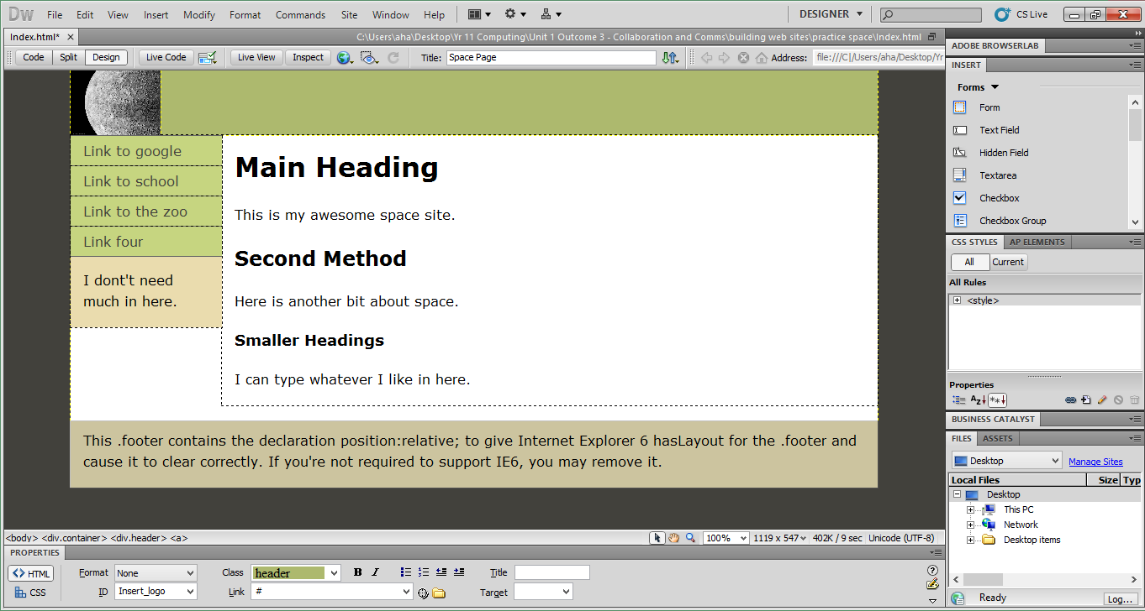

1. 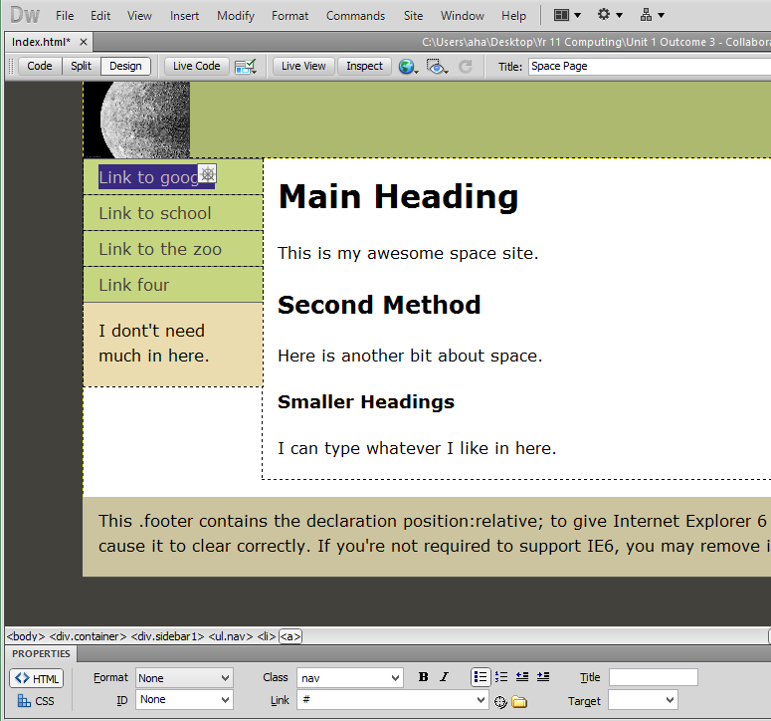To create a link, select (highlight) the text that will be the link
2. 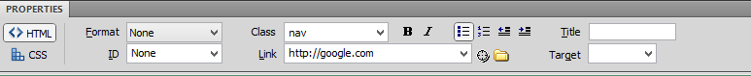Enter the full link in the link tab on the properties menu strip. You need the http:// or it will look for the file in the same location as the index.html
3. 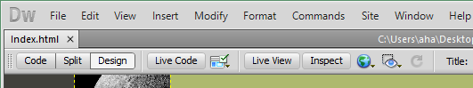You can now test your site by selecting the globe in the top bar
4. Choose to open in the browser of your choice. Once open you will have a new tab.

Click on the link to google to check it works.

1. 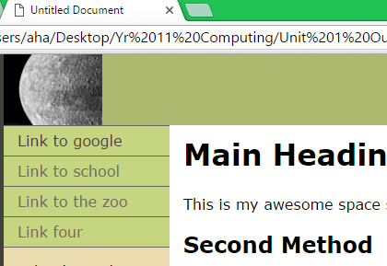However, You can see it says “Untitled Document” we need to fix this.
2. 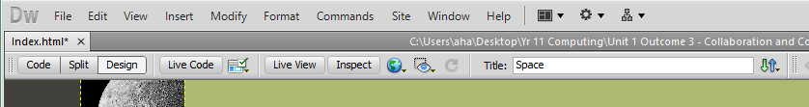In dream weaver, at the top, near the globe is the Title, change it to something meaningful. Like space.
3. Make sure to save your page. If the file name has an \* after it, it means you have not saved your file and any changes will not appear when you (run) open the file in a browser.
4. 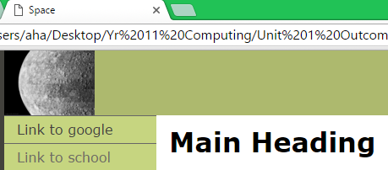run your page again. It should now have a meaningful title in the browser.
5. I don’t like the default colours. I would like to change them. In a web page each section can have a different format. I want to change the footer. The footer is a container and part of the body hierarchy. So it inherits all its properties from those objects. I want to change the footer all by itself. So I need to put the cursor in the footer area or click on <footer> from the object hierarchy list. See image below.

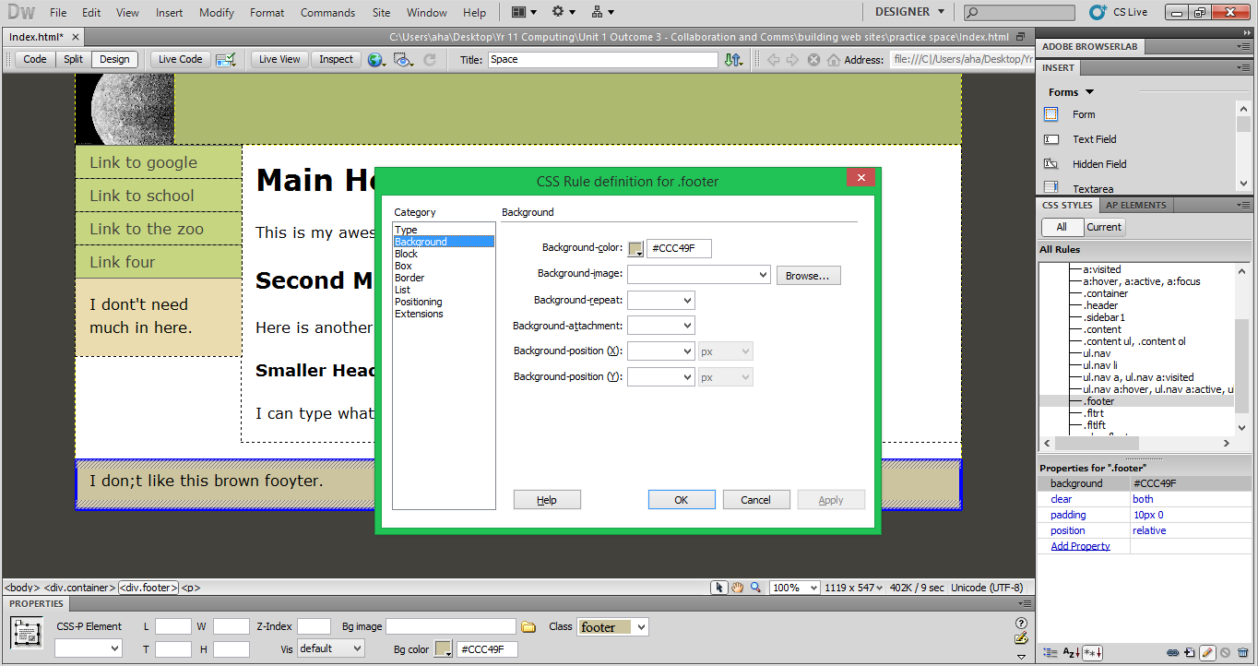

Once this is selected, when I change the properties it will only change them for the footer object.

1. Next I need to select the footer from the CSS Styles tab on the right. Double click on .footer

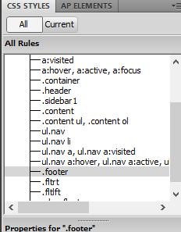

1. Then the properties box will pop up and you can change many properties for the footer
2. 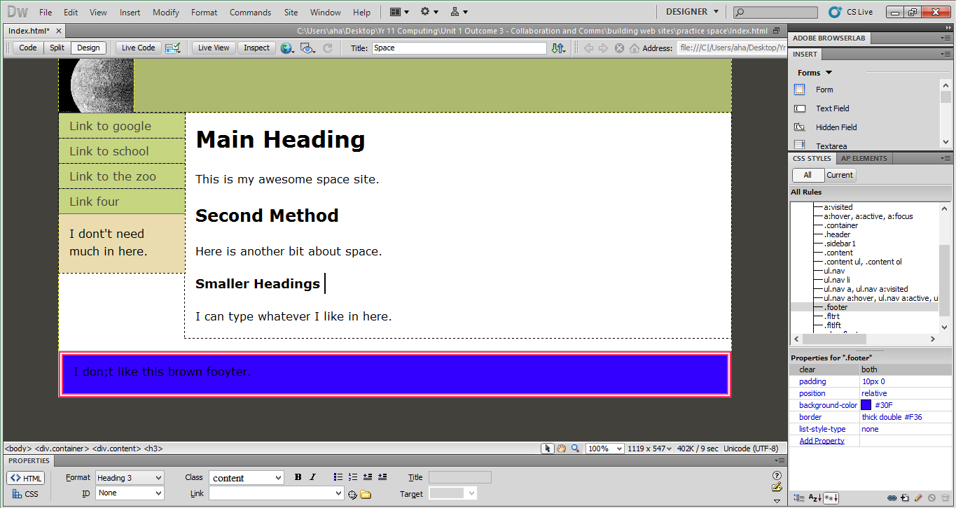I was able to change the background colour and the border of the footer only.

The changes that I made now show up in the properties window

You can also choose add property from the drop down list to make other changes.

1. 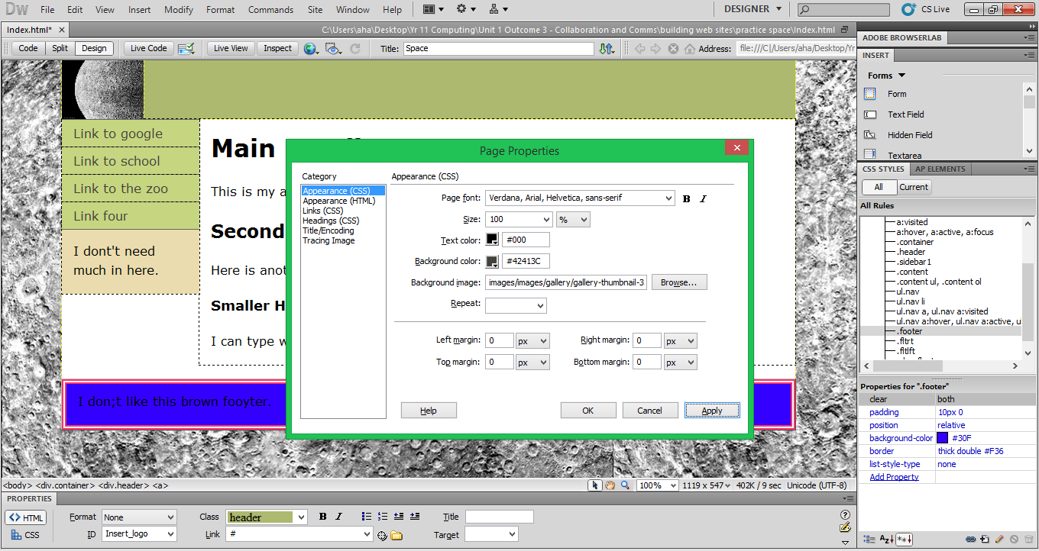To change the properties for the entire site you can right click anywhere on the page and choose “Page Properties” from the bottom of the list. I changed the background image for the page.
2. Remember to save so that when you test all your changes appear on the site.
3. Go customise as many formats that you can to make your own space site.
4. 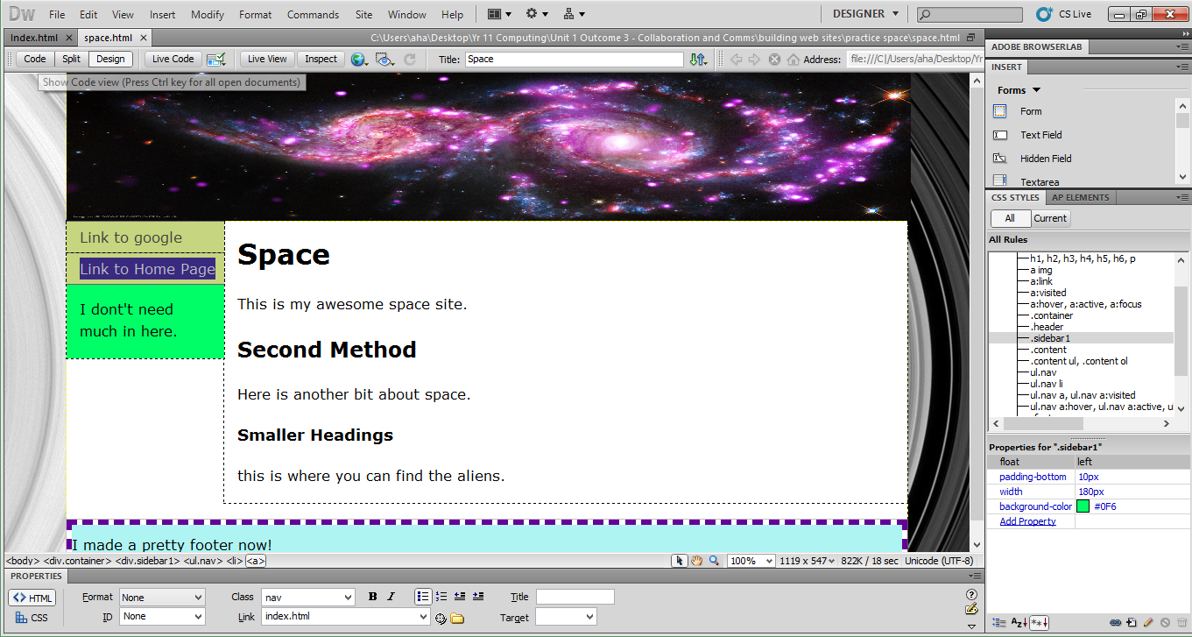Then you can make another page which you will be able to link between.
5. I made a second page called space. I chose some different images and then I made a link to the homepage. Remember a home page should always be called Index